TERRAFORM IS INFRASTRUCTURE AS A CODE TOOL

Terraform is an open-source infrastructure provisioning tool which means that we can create the resources on aws or azure or gcp or anyother cloud

it allows you to define and manage your infrastructure using a declarative language : We write the code in the language known as HCL (hashicorp configuration language)

We dont have to learn HCL ….we can use documentation provided by terraform and use those documents to write the code ….

Terraform allows you to create, modify, and destroy infrastructure resources across different cloud providers, such as AWS, Azure, GCP, etc. It describes the desire state of the infrastructure on the premises environment.

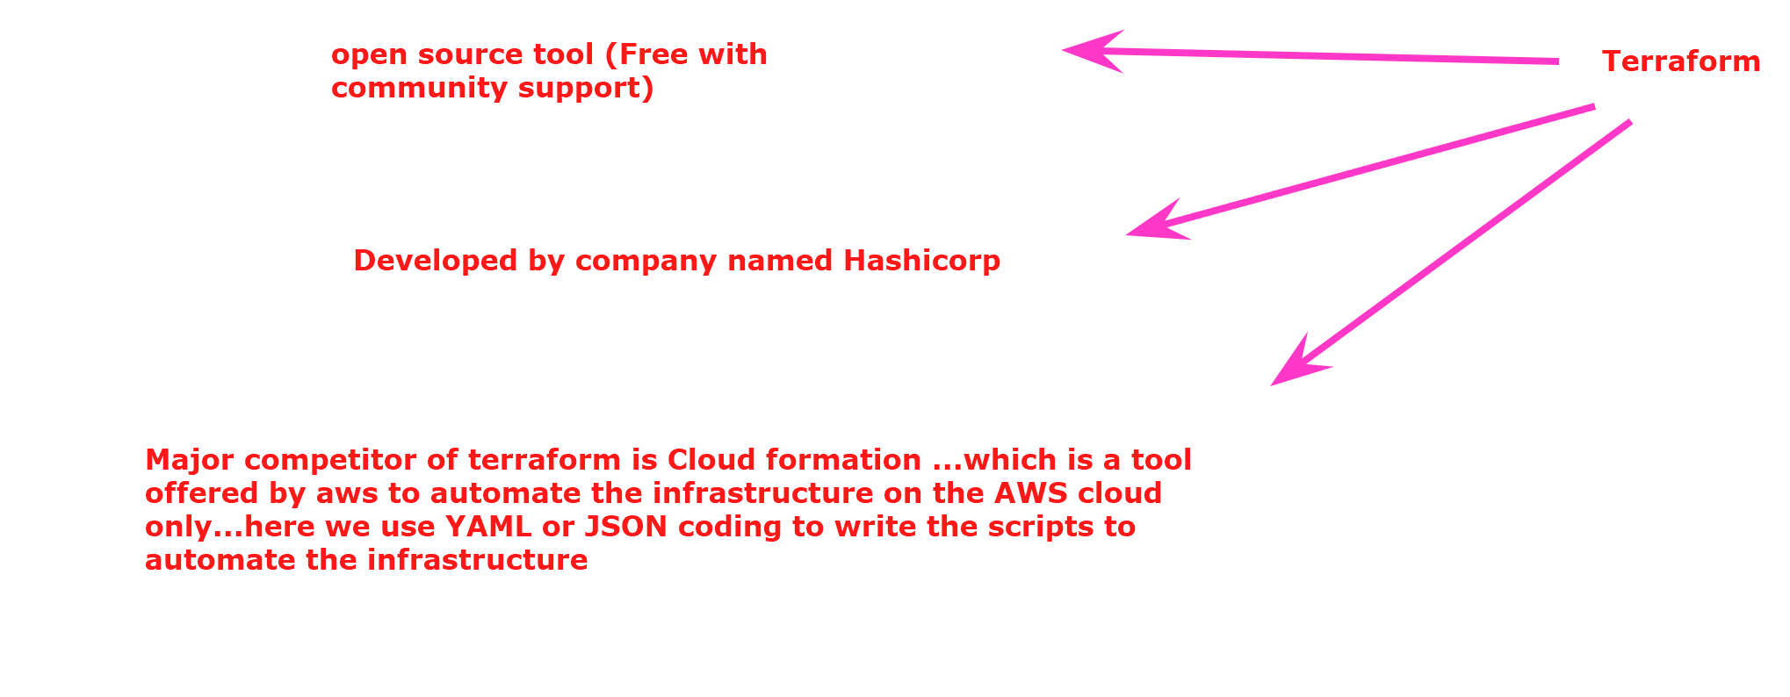

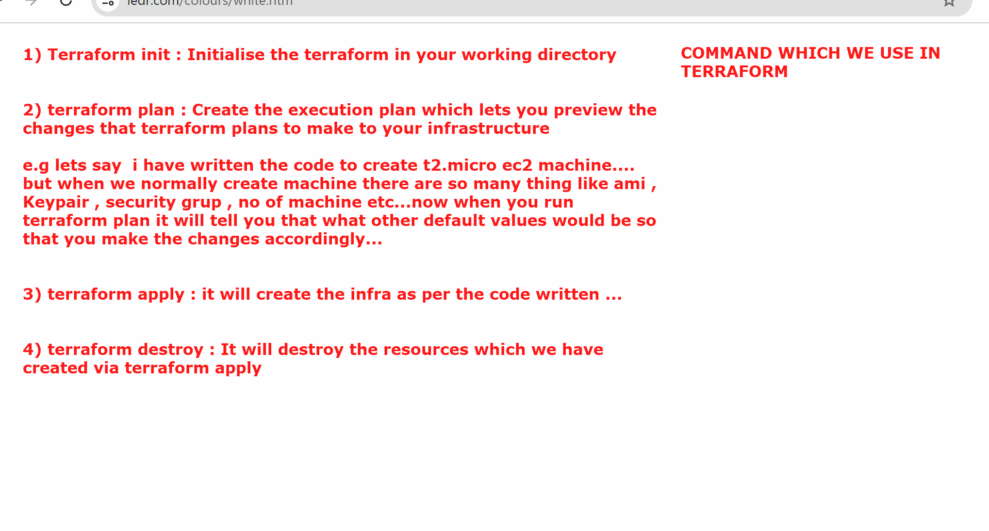

## we will create a ubuntu ec2 machine wherein i will install terraform to perform the tasks in the cloud

We will create an ec2 machine( this ec2 machine could any machine it be your laptop this is where the developer will work) -> install terraform -> we will connect to aws account via access key and secret access -> we write the code to create infra in aws

LAB:

- Create a ubuntu ec2 (t3.medium)

FOR INSTALLATION CHECK

Go to https://developer.hashicorp.com/terraform/install?product_intent=terraform to download terraform …
If you are using windows you can download the zip file and when you open the zip there would be a single file which you copy in your working directory where you are writing the code

But in our case we are using ubuntu

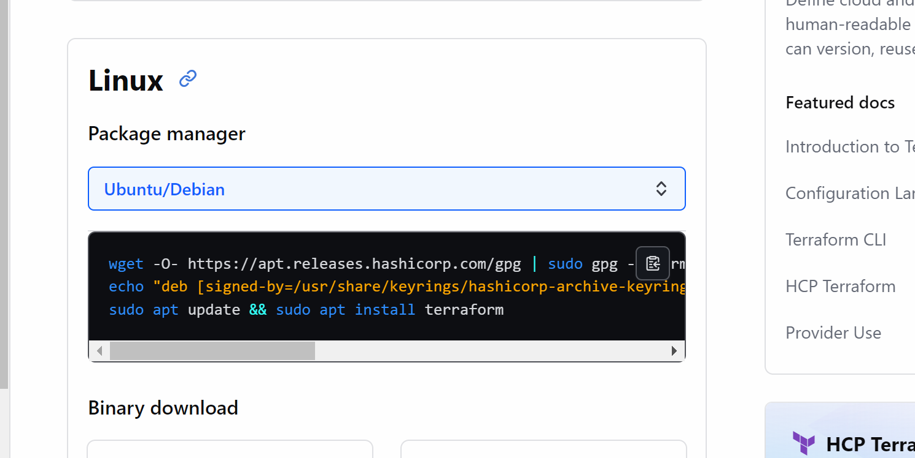

sudo su

wget -O- https://apt.releases.hashicorp.com/gpg | sudo gpg --dearmor -o /usr/share/keyrings/hashicorp-archive-keyring.gpg
echo "deb [signed-by=/usr/share/keyrings/hashicorp-archive-keyring.gpg] https://apt.releases.hashicorp.com $(lsb_release -cs) main" | sudo tee /etc/apt/sources.list.d/hashicorp.list
sudo apt update && sudo apt install terraform

(these are these different commands need to executed one by one)

After this done we can validate if terraform is installed by running terraform --version

####################

Lets now create a directory inside the machine where we will write terraform scripts

# mkdir terraform
# cd terraform

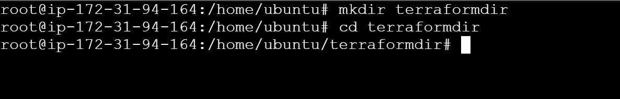

######

First lets generate the Access key and secret access key in the nodes

Go to IAM -> click on user -> security credentials
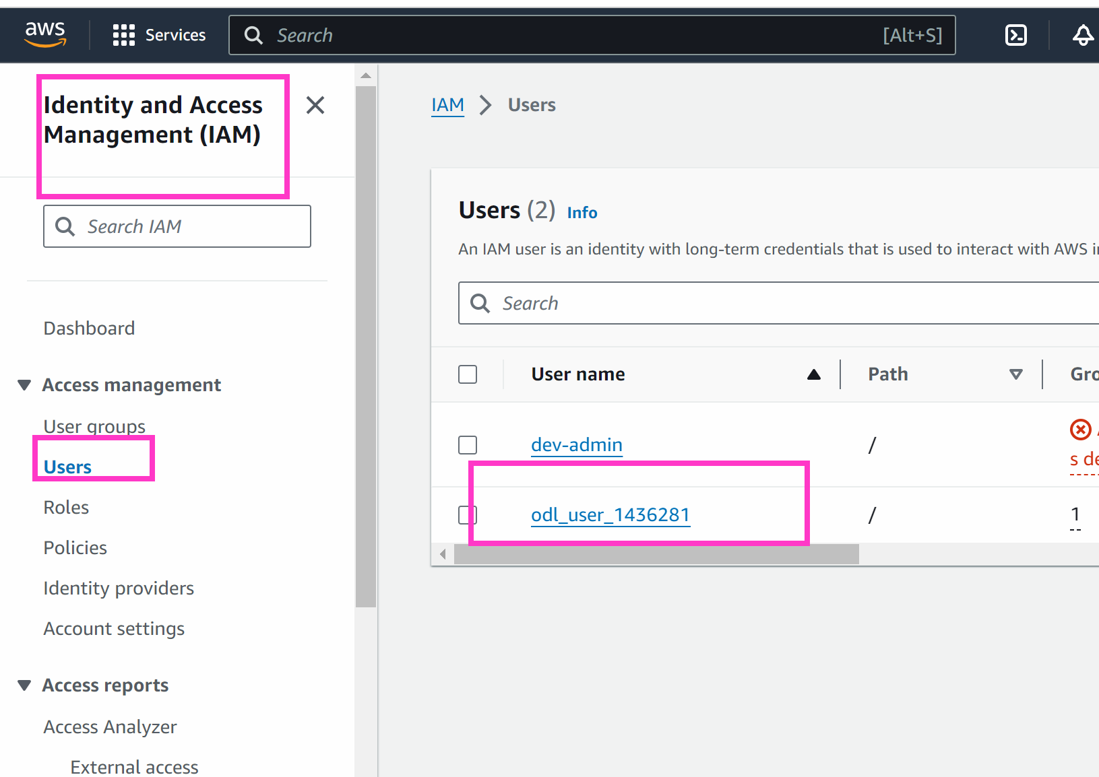

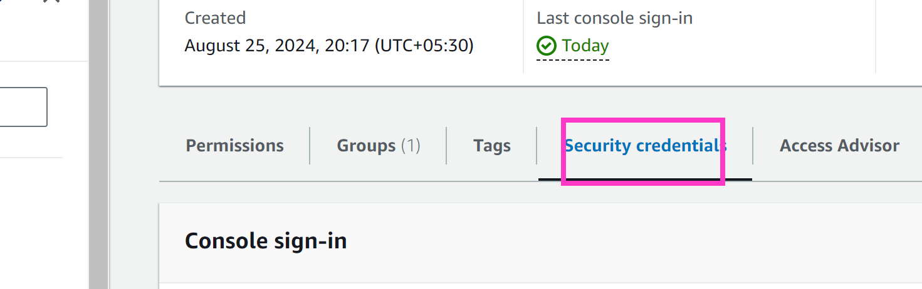
Scroll down
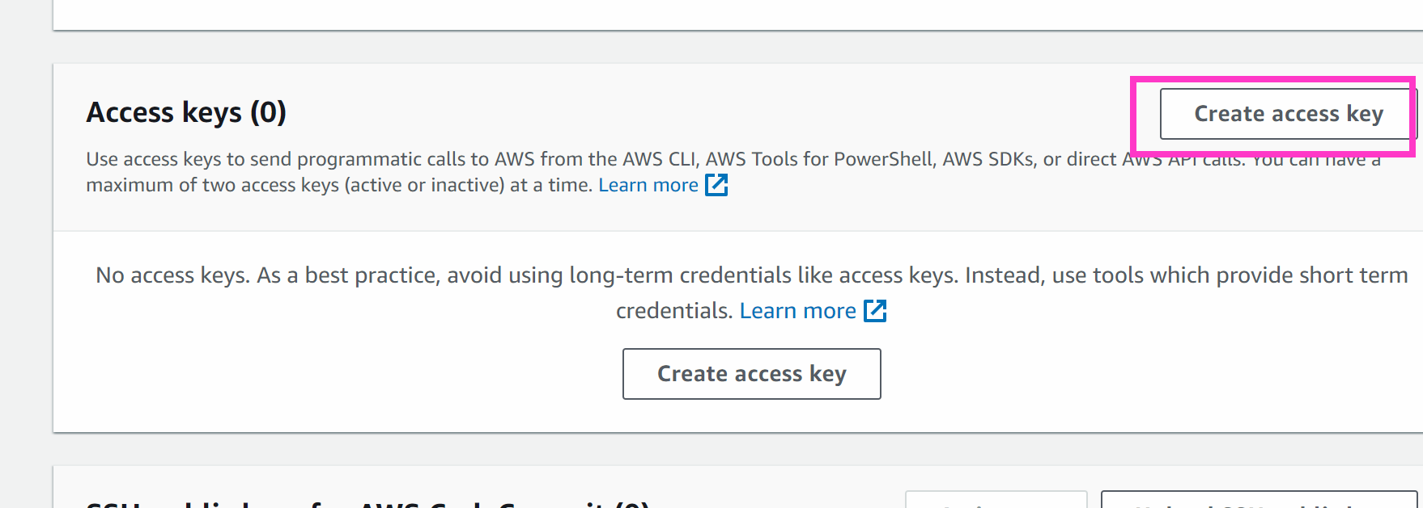

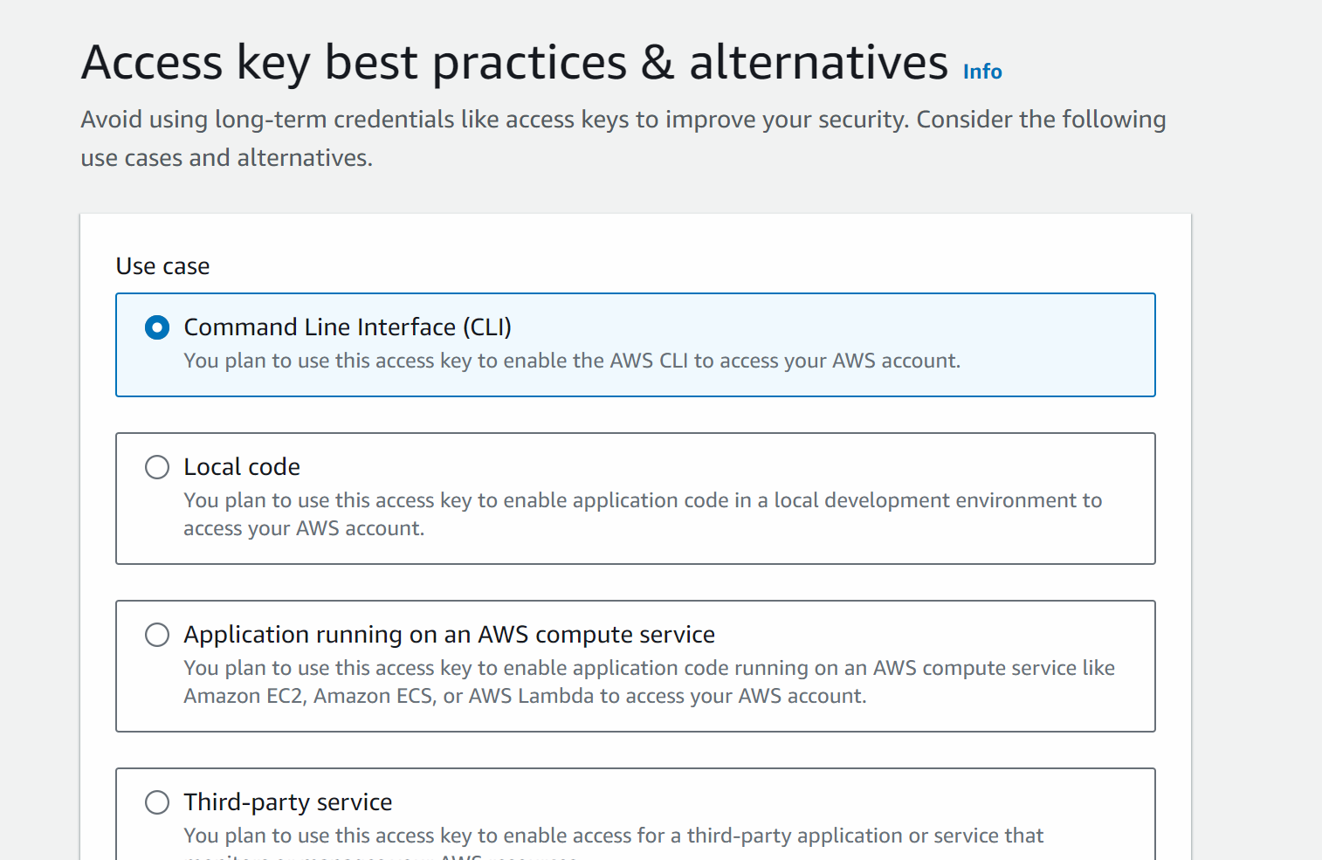

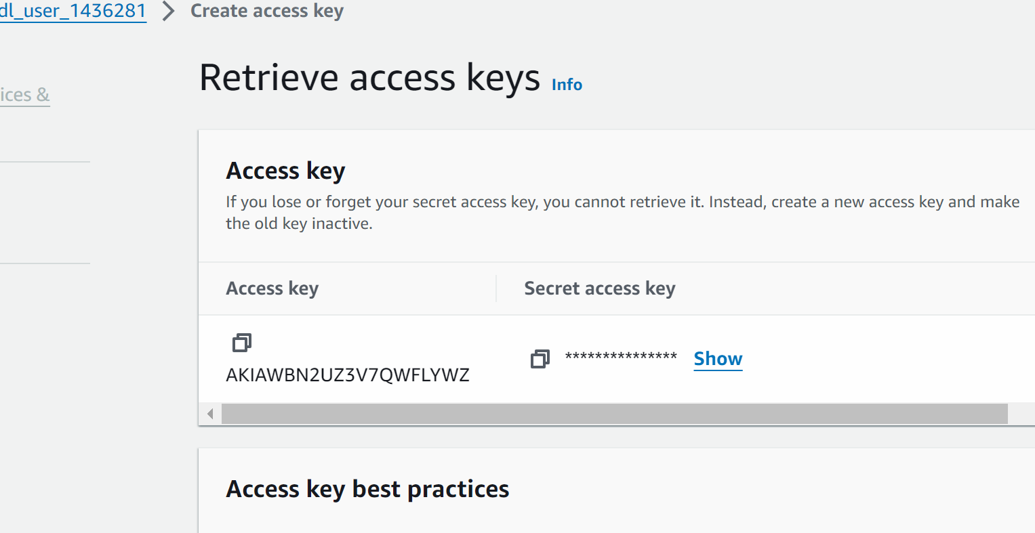

Copy in notepad

#######

Now we will write terraform script…by which we will create ec2 machine and also connect to aws account via access key and secret key

Documentation : https://registry.terraform.io/providers/hashicorp/aws/latest/docs

nano connection.tf
(remember that all the terraform scripts ends with .tf)

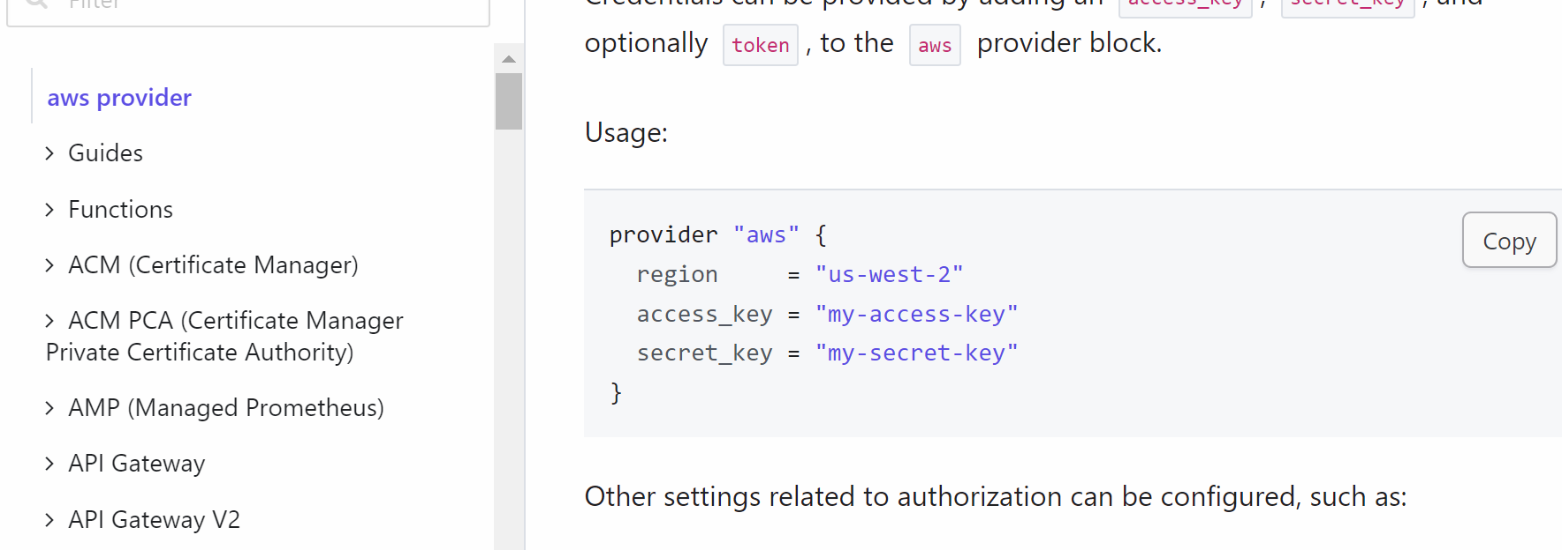

provider "aws" {
region = "us-east-1"
access_key = "my-access-key"
secret_key = "my-secret-key"
}

Here you need to update the region in which your resources would be created
The access key and seret access key also need to be updated

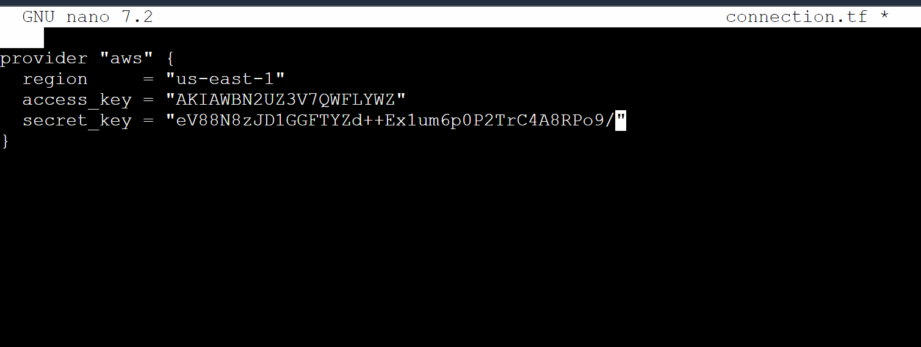
## here the accesskey and secret access is the keys which we created above

To come out of the file press ctrl x -> y - > enter

### Do till this point

Now we need to write the code to create ec2 instance via terraform…so we will create one more file with lets say name : ec2-sl.tf

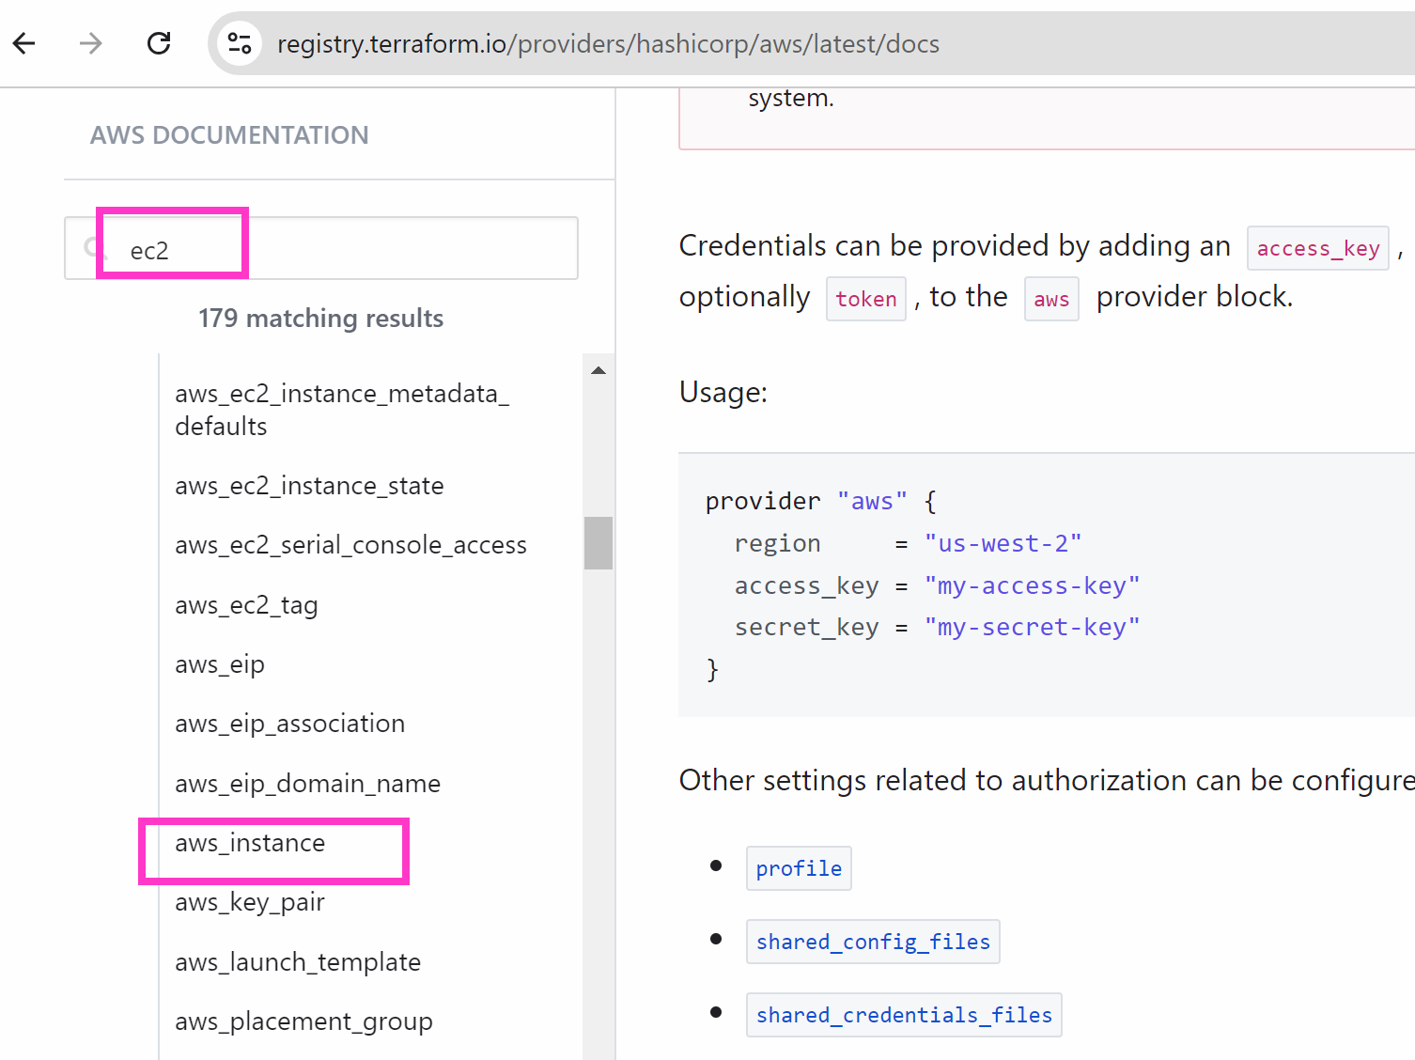

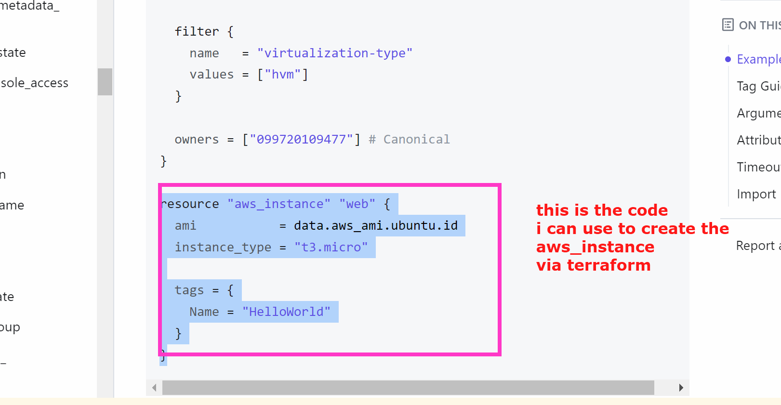

resource "aws_instance" "web" {
ami = "We will update he ami which need to create"
instance_type = "t3.micro"
tags = {
Name = "machine1"
}
}

We need to get the ami id

Either we can take the ami id from google or ask solution architect or go to aws -> ec2 -> instance- launch instance
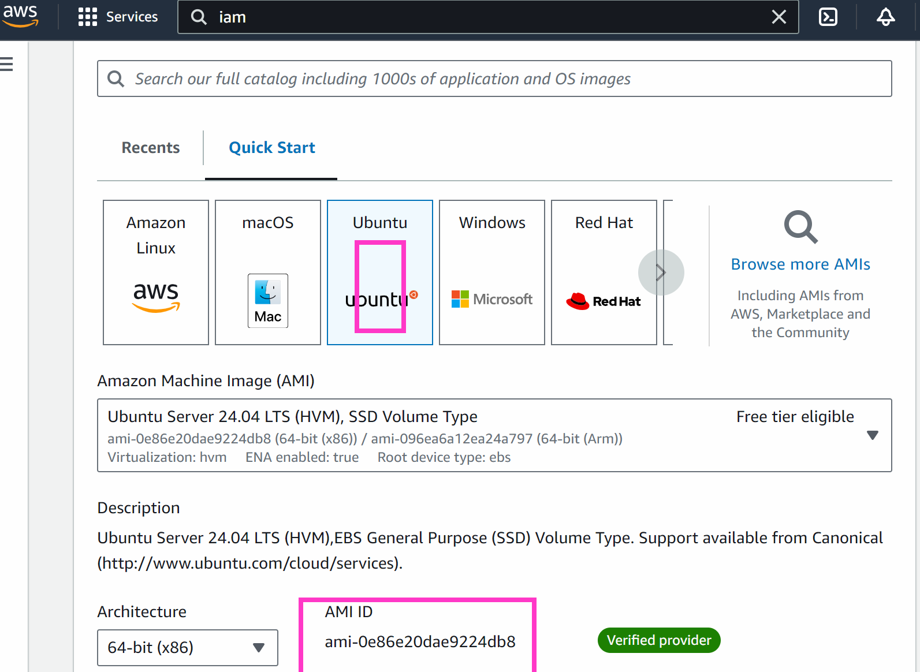

We can check thee ami id in this way

resource "aws_instance" "web" {
ami = "ami-0e86e20dae9224db8"
instance_type = "t3.micro"

tags = {
Name = "machine1"
}
}

Go to terraform ec2 machine:
nano ec2-sl.tf
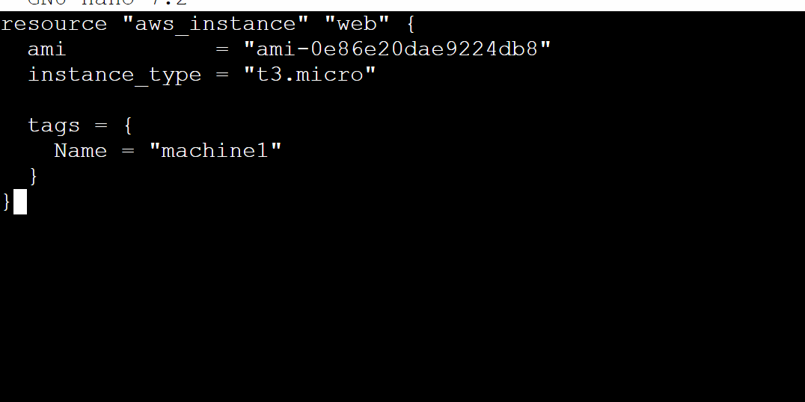

To come out of the file : press ctrl x -> y -> enter button

### now we have written two terraform files (tf) files now we need to execute them

terraform init # this will initialise the terraform in your working directory

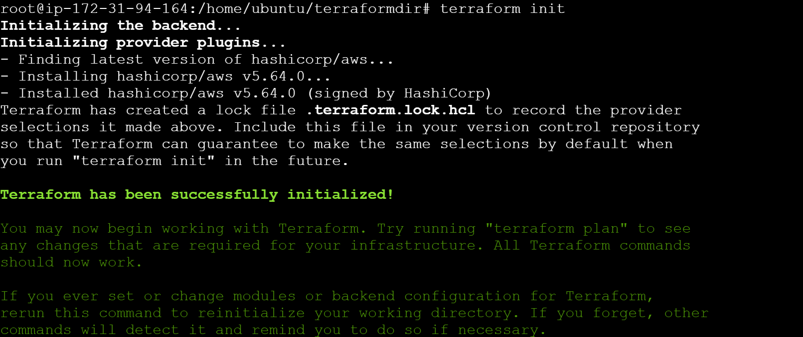

##
terraform apply --auto-approve
(when you write auto-approve it means that if you not ask you to confirm whether infra need to be created or not …it will create it)
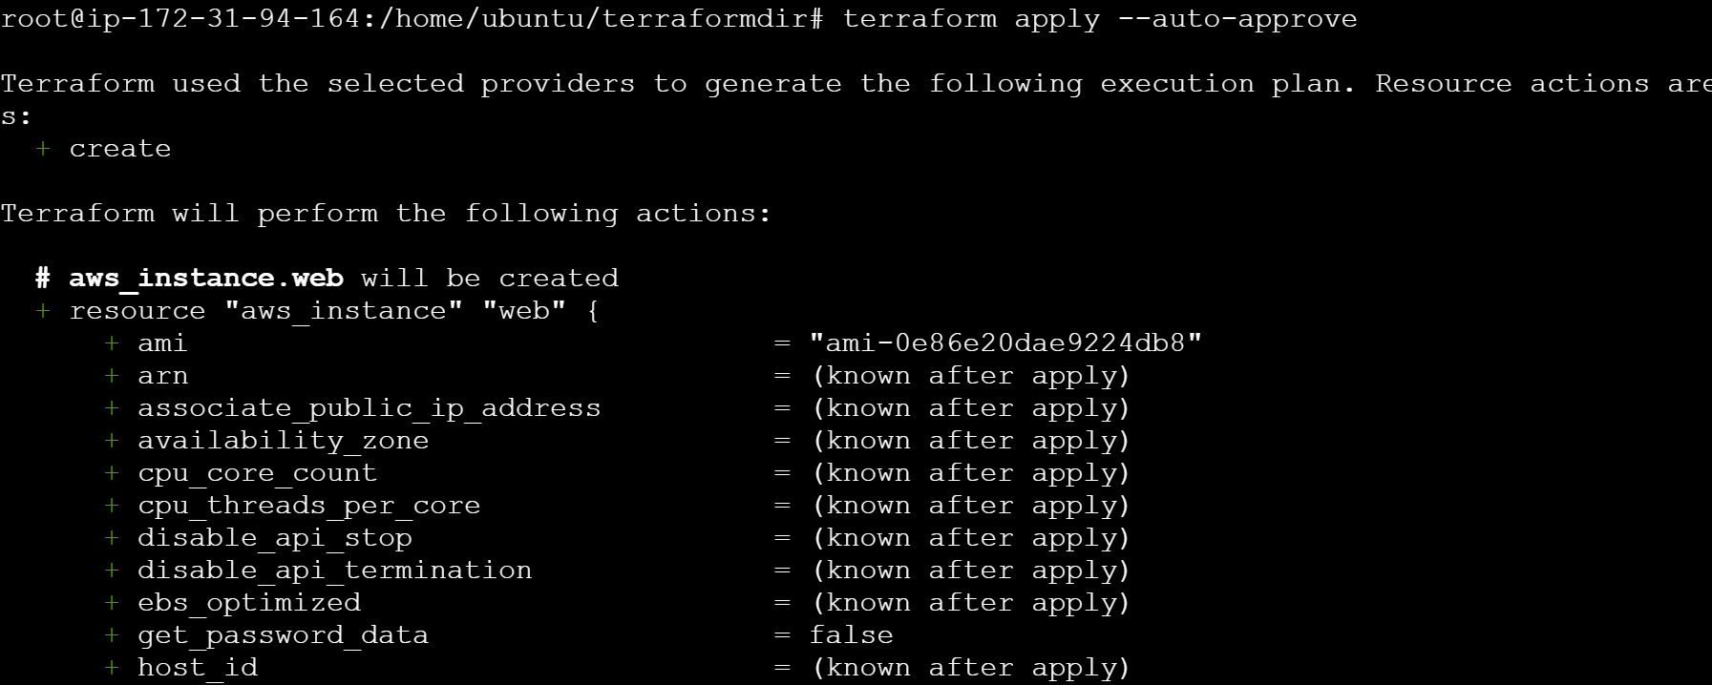

#####

You can see the resources created
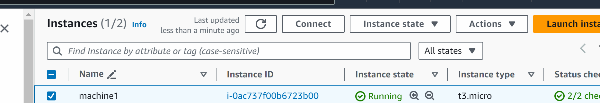

###############
Let suppose we want to destroy the resources
# terraform destroy

This will destroy the resources which we created above for us.
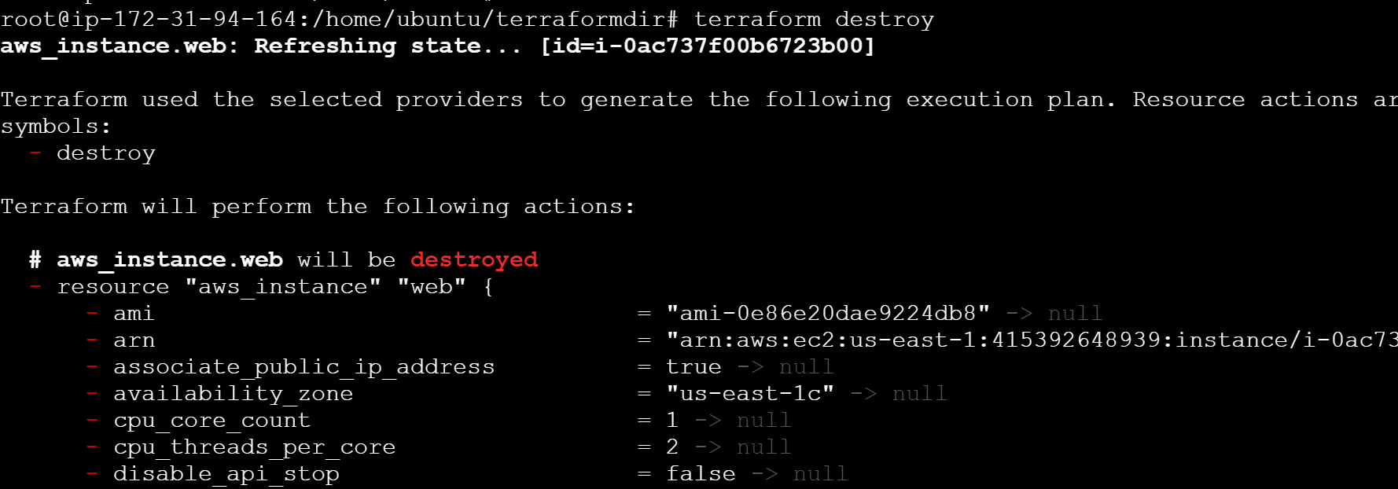
############

Working with Cloudformation
AWS cloudformation is a service offered by aws that helps you set up and manage aws resources like servers, databases, and networking components. Instead of manually configuring these resources through aws management console we can use cloudformation to them in a text file. This file we call it as a cloudformation template

In the cloudformation we write a template (text file written in json , yaml ) where we create resources which we call it as stacks
For example: if we create ec2 machine thats a stack
Key concepts:
Template: A cloudformation template is a text file written in json or yaml (data serialisation language) format
In template we describe all the resources and their configuration that you want to create and manage in your aws environment
Stacks: when you use a cloudformation template to create resources, the collection of those resources is called a stack
For example: a stack can include a ec2, s3 etc

Benefits of using cloud formation 👍

- Automation : Instead of manually setting up resources you automate the process with a template
- Consistency : templates ensures that your infra is set up in same way everytime , leading to consistent environment
- Version control

Lets do the lab 👍

Go to cloudformation

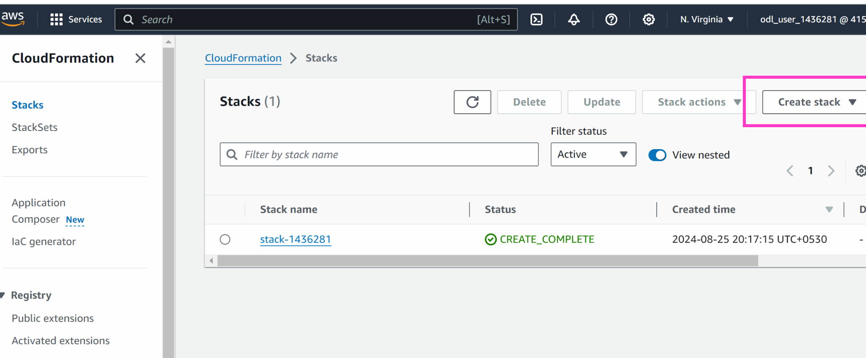

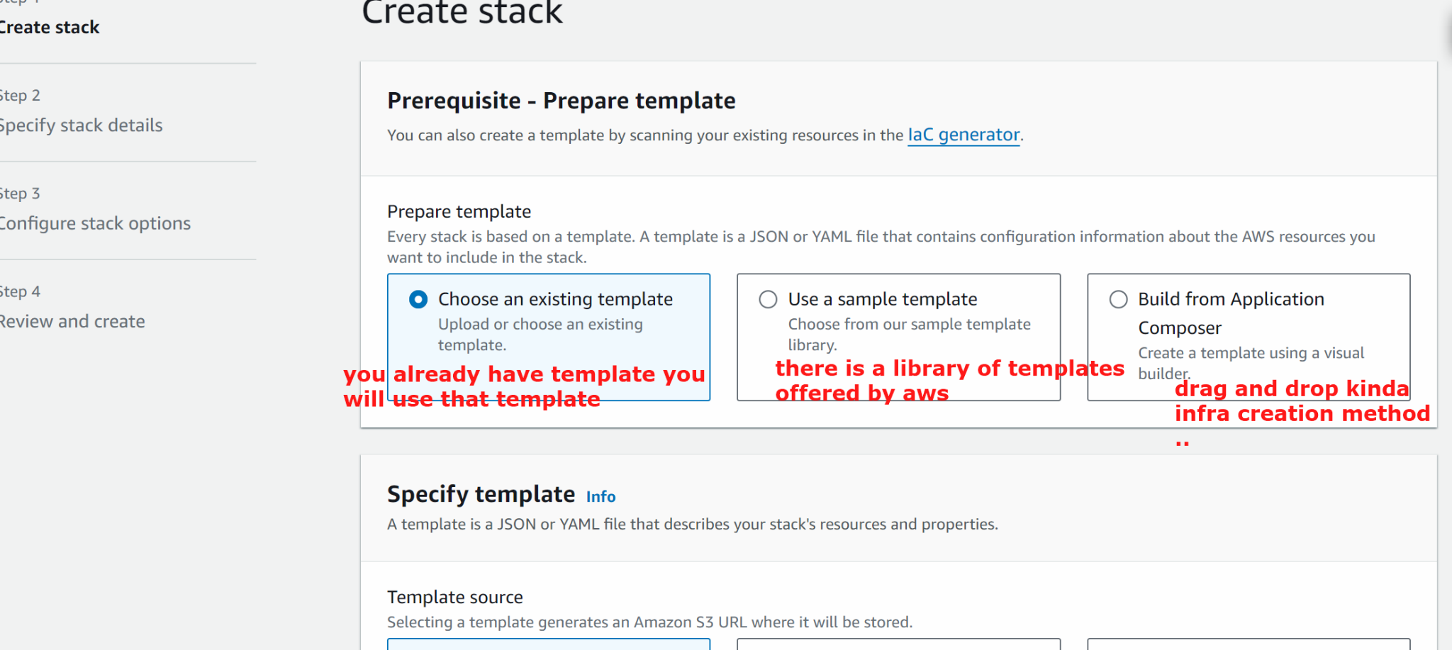

####
We have the code in https://github.com/akshu20791/cloudformation
(fork the repo in your github)

Login to your github
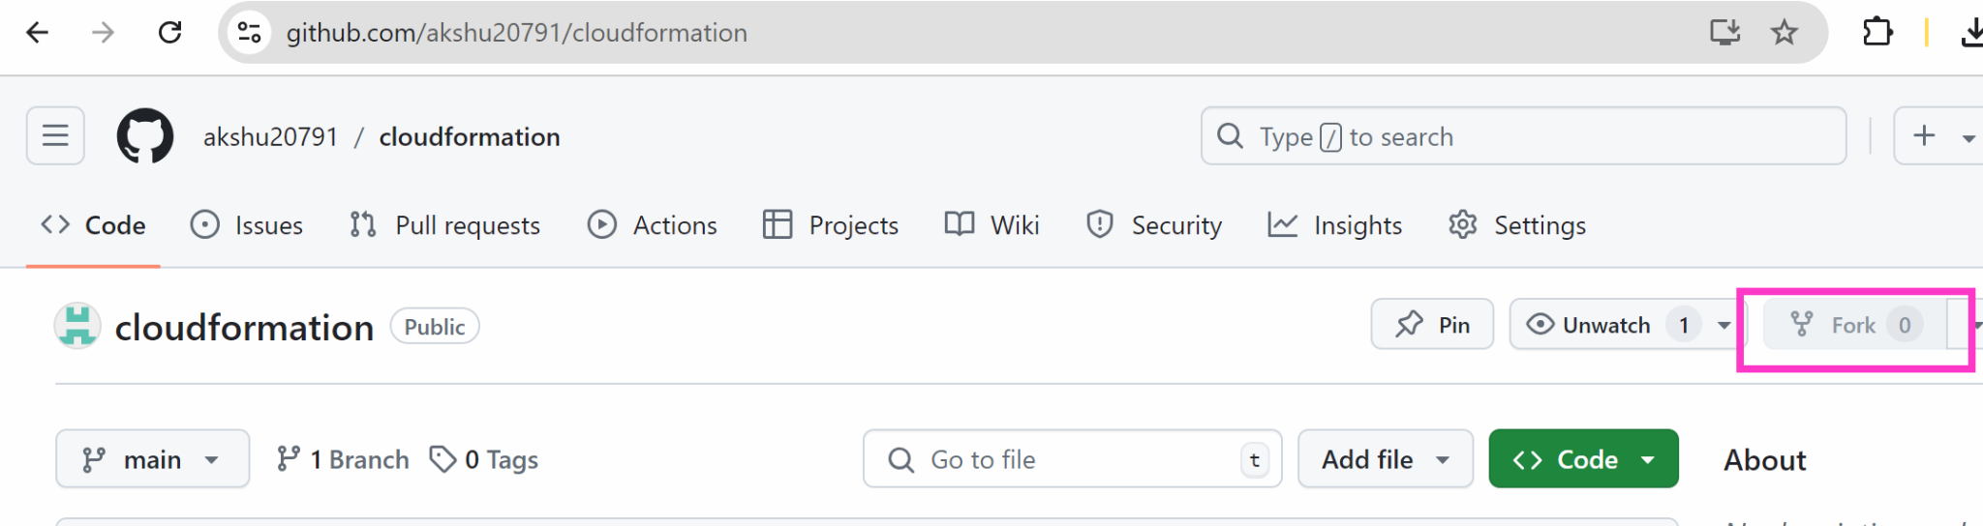

##
Go back to cloudformation
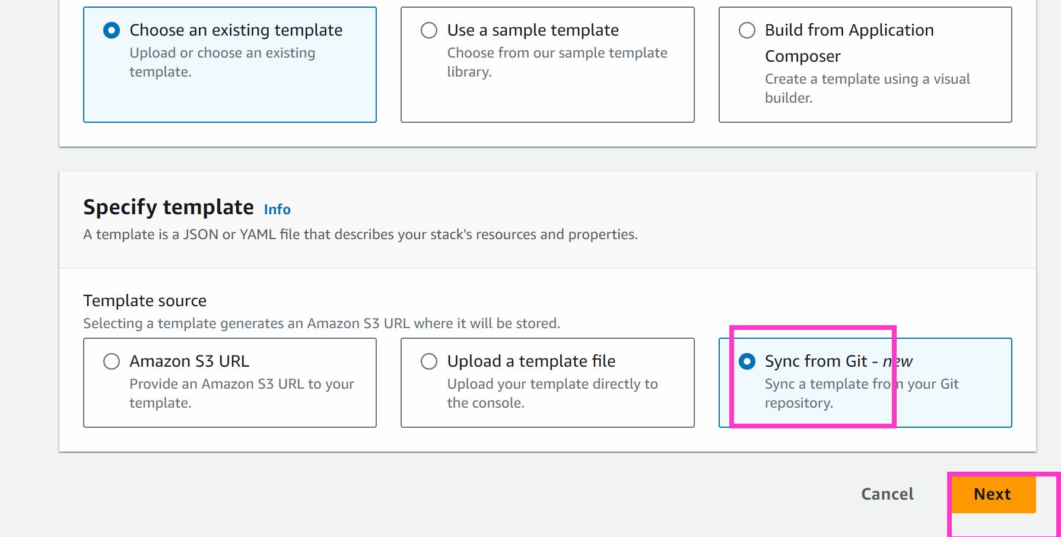

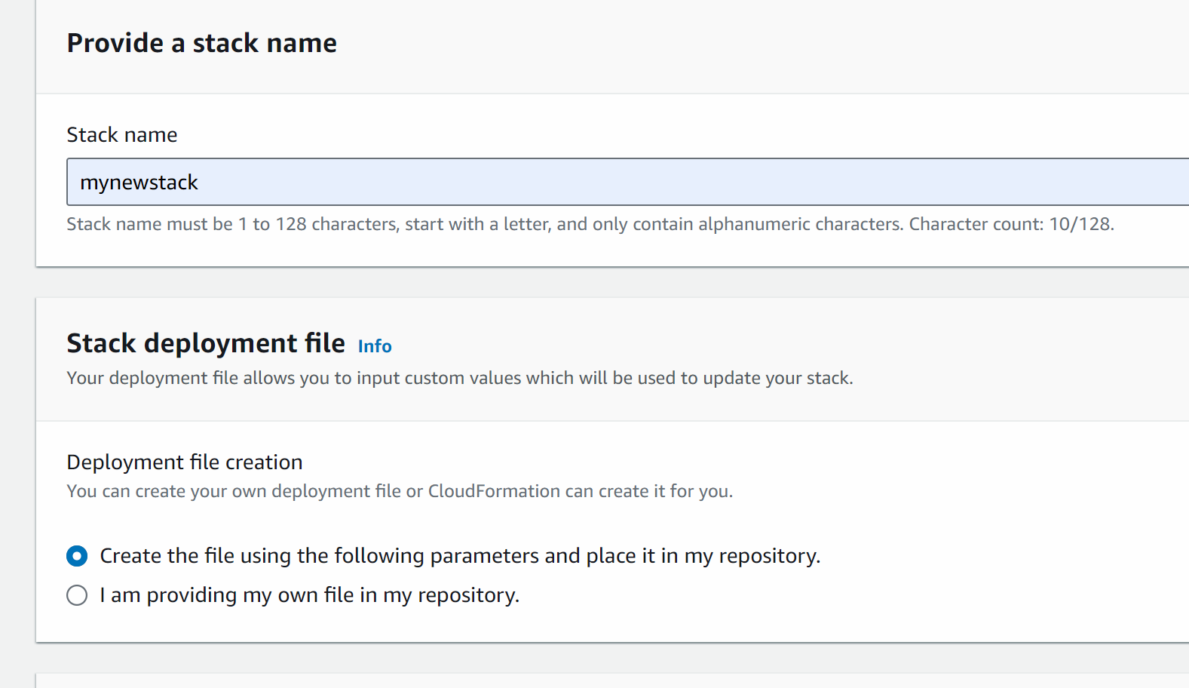

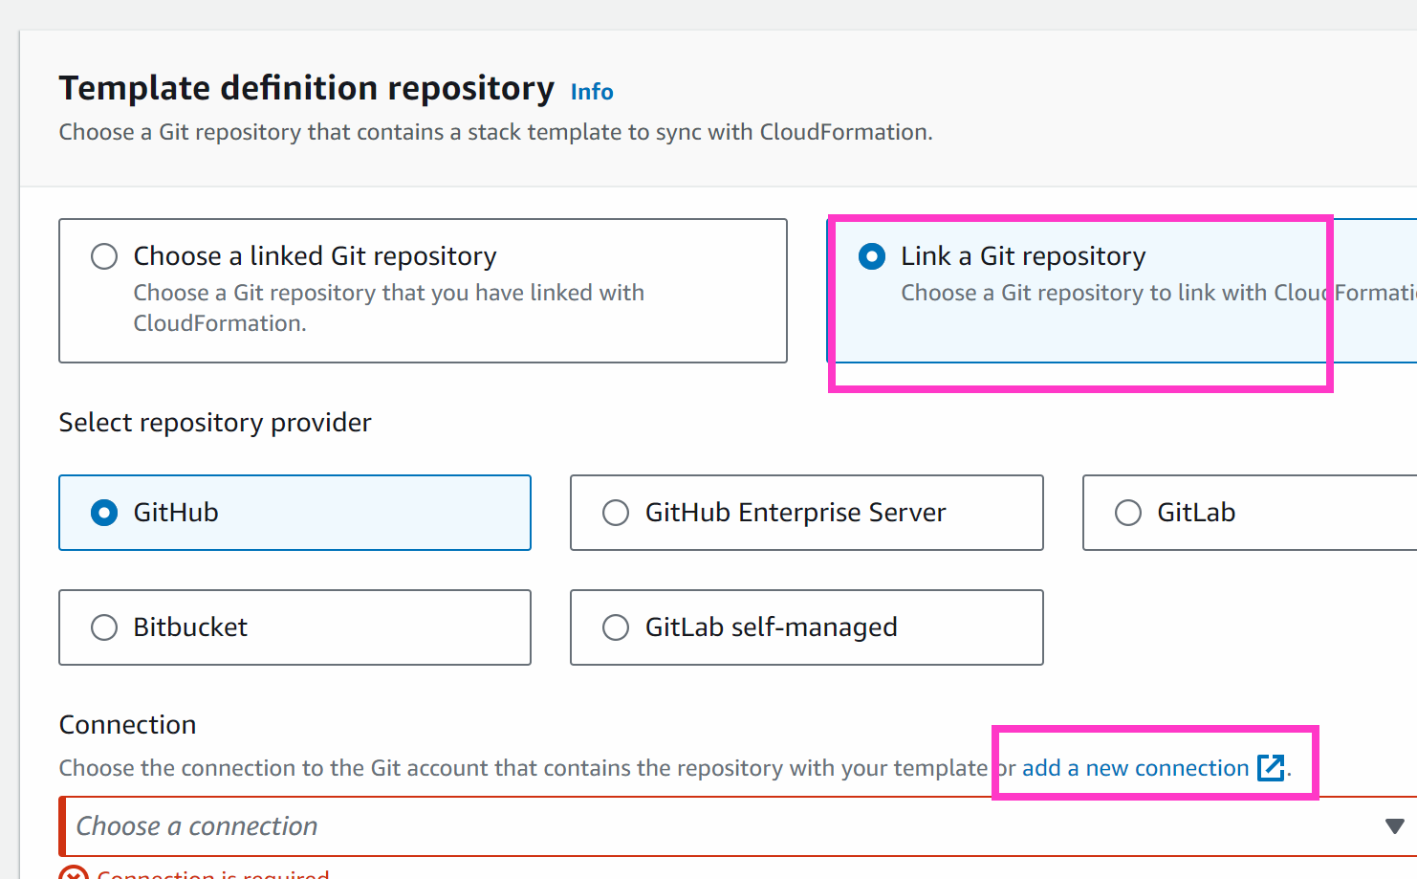

When you click on add new connection this will take u new page

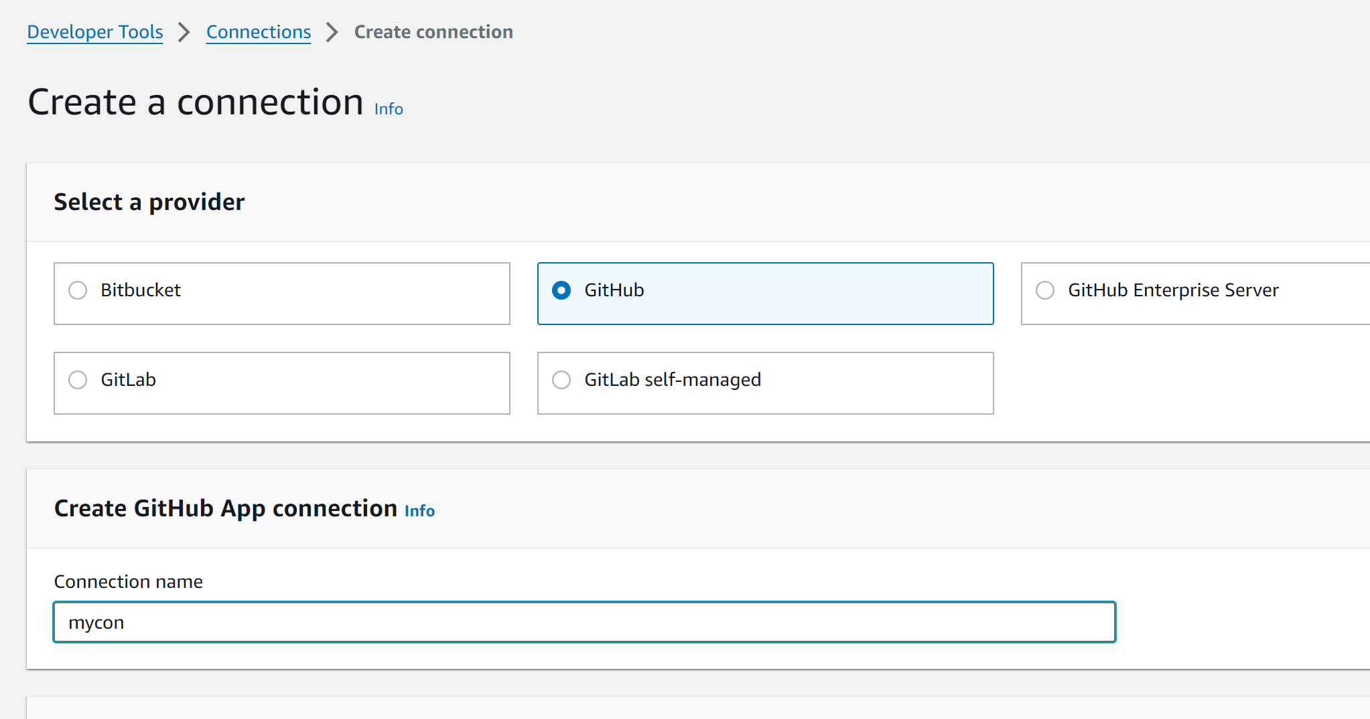

Connect to github
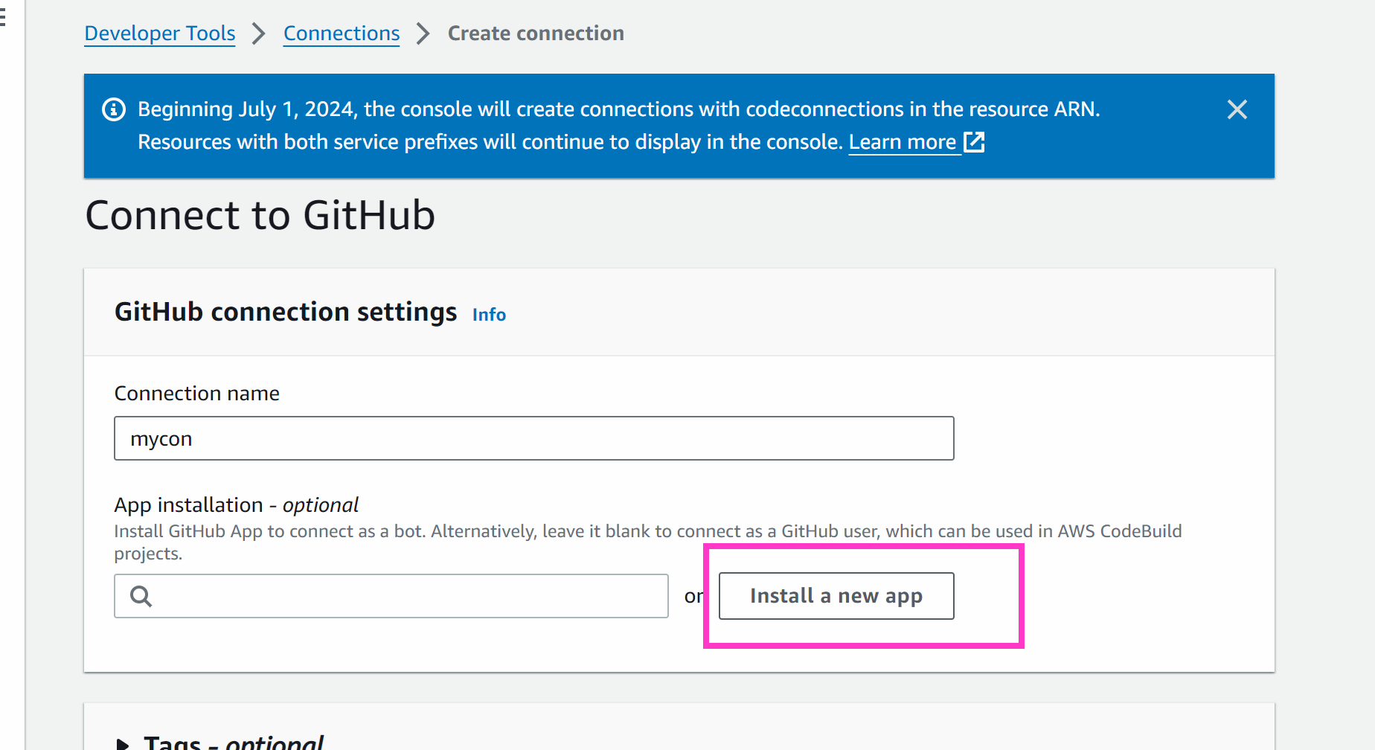
A new page will open (of github) (you need to ensure that you are logged in to your github account)
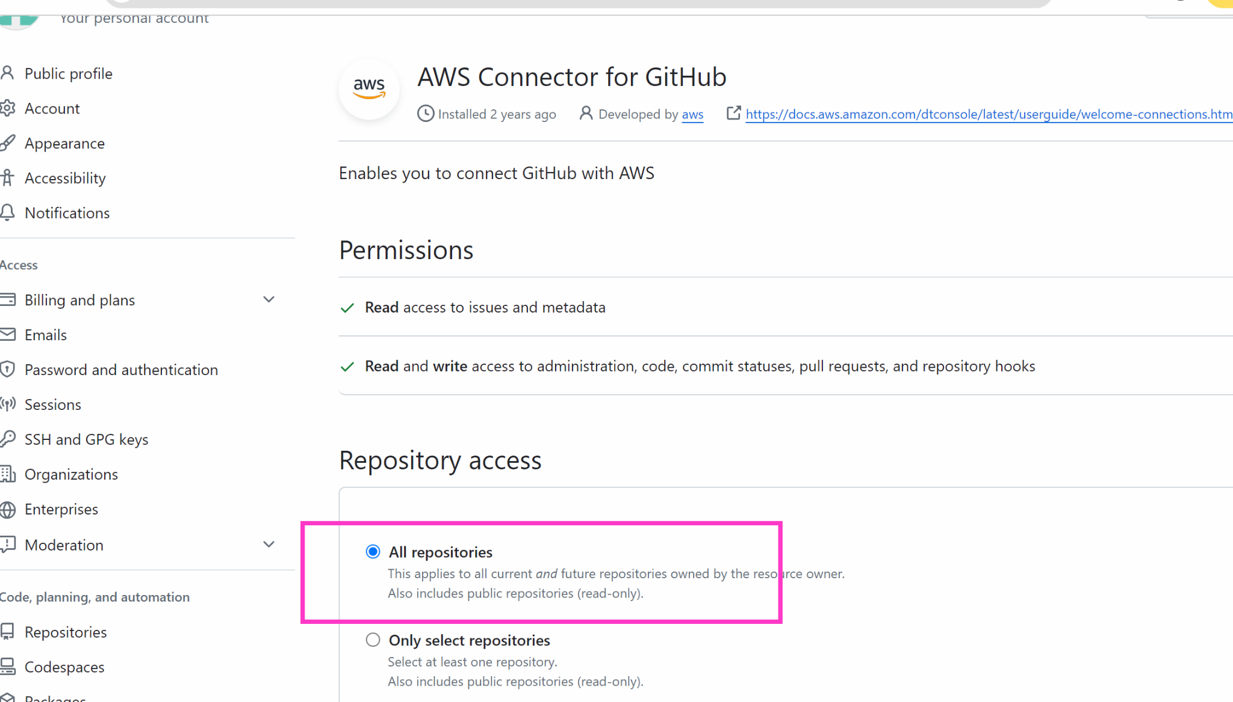

Save
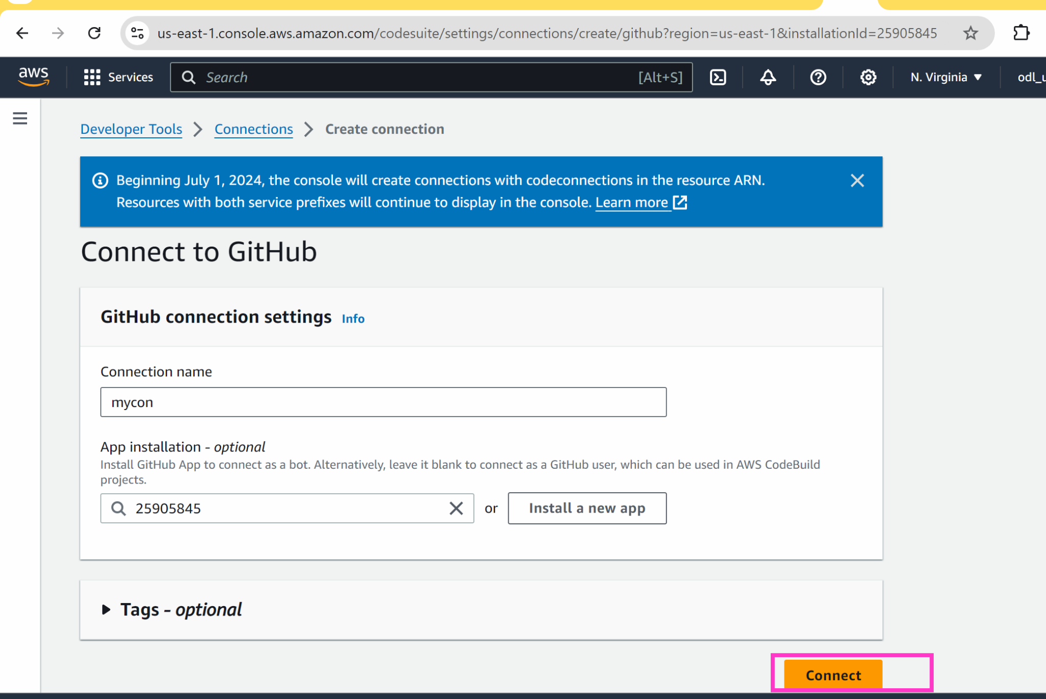

Go back to cloudformation page

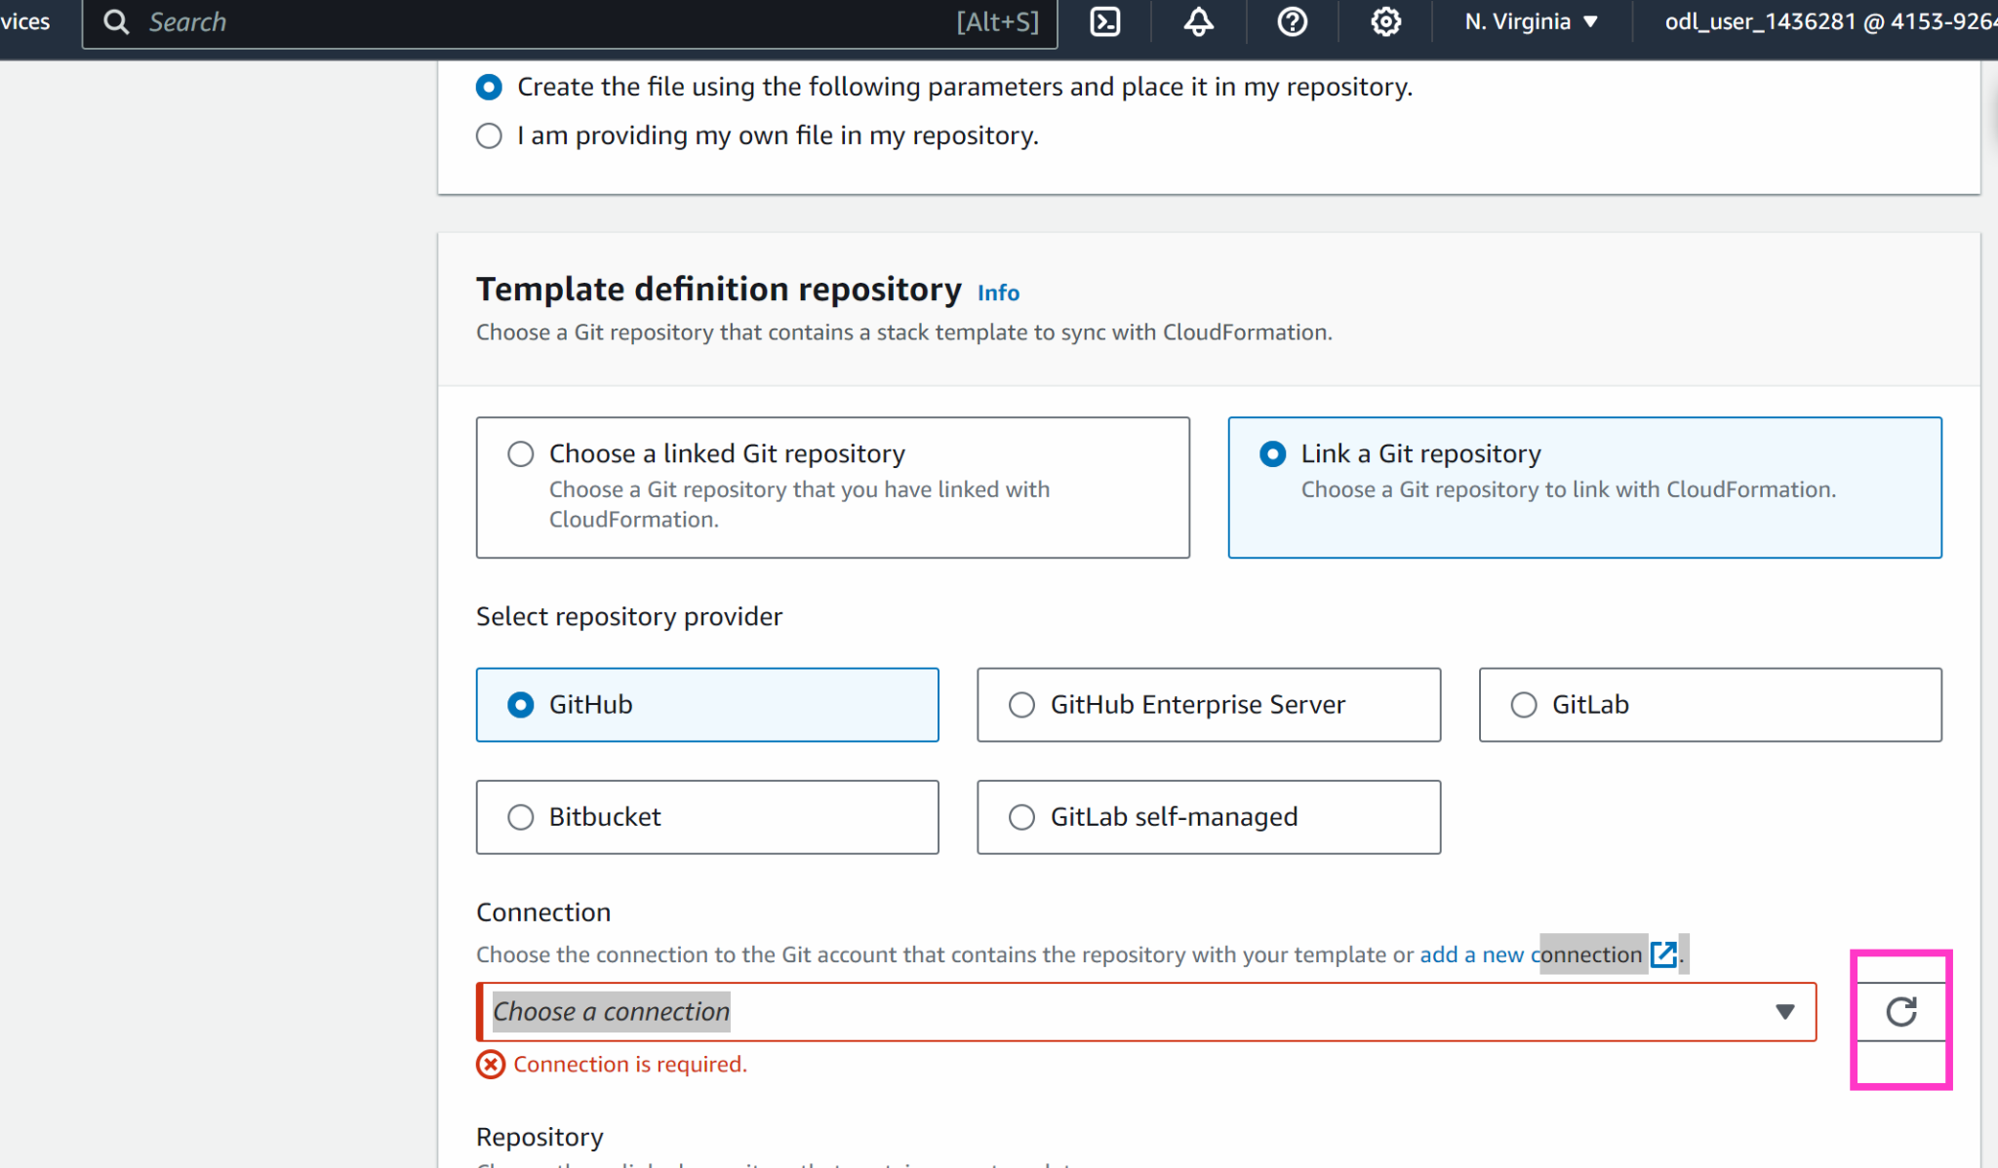

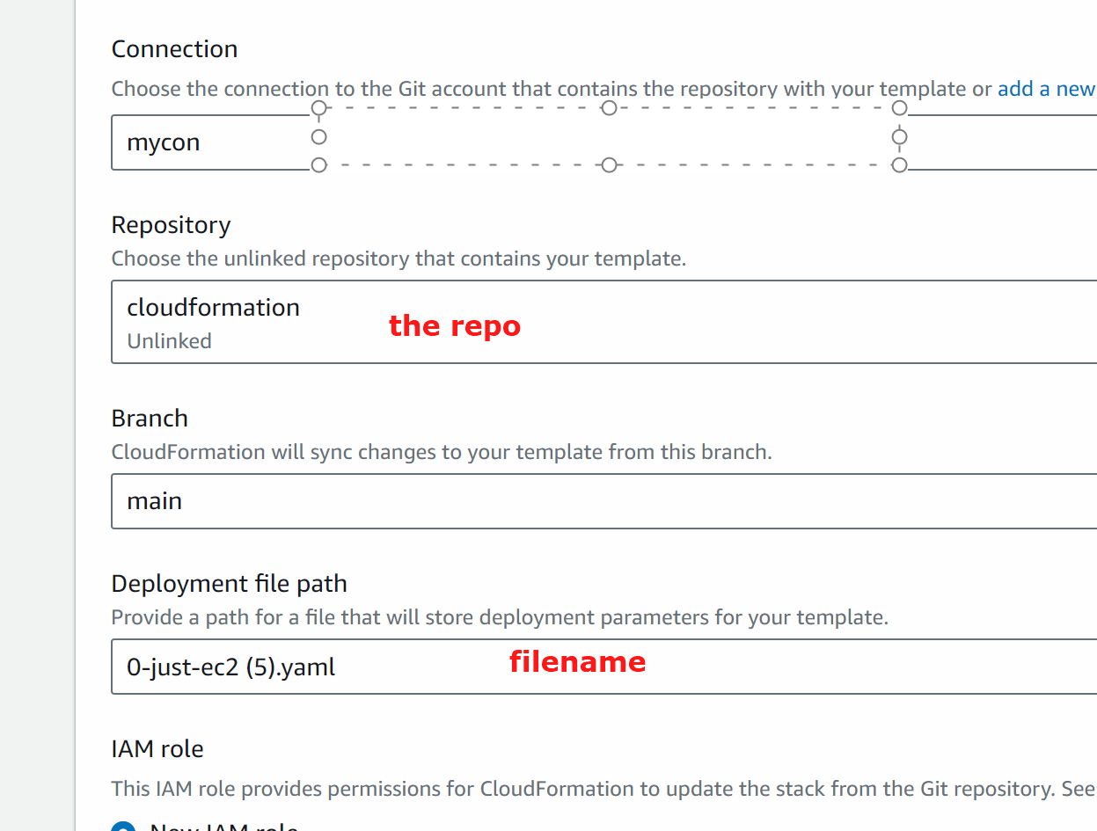

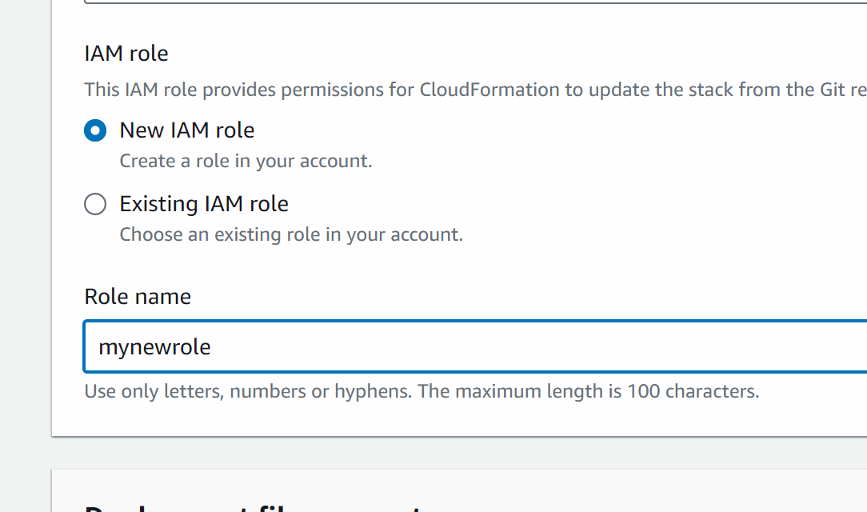

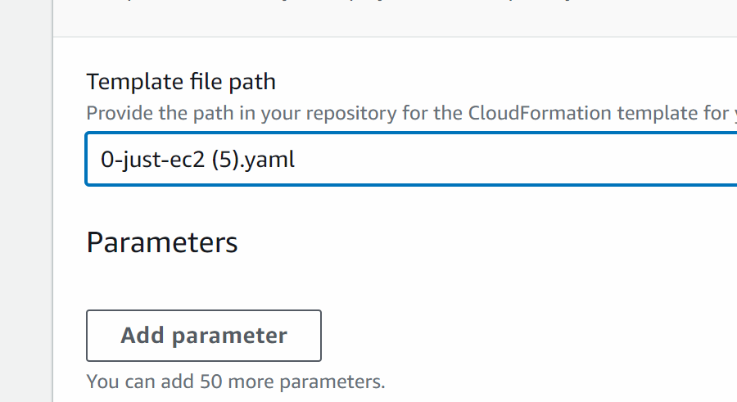

Go to iam and create a new role
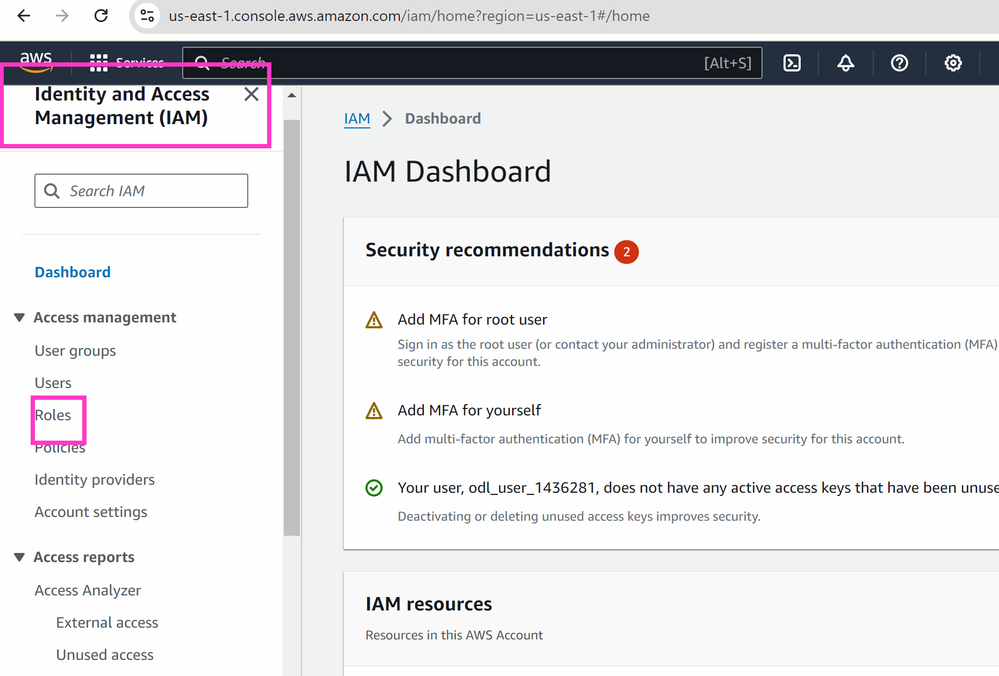

Create role

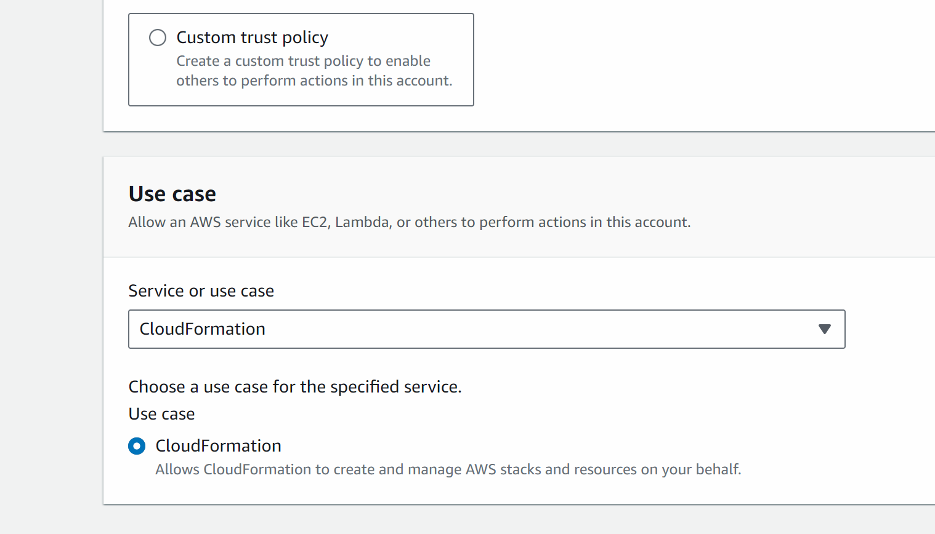

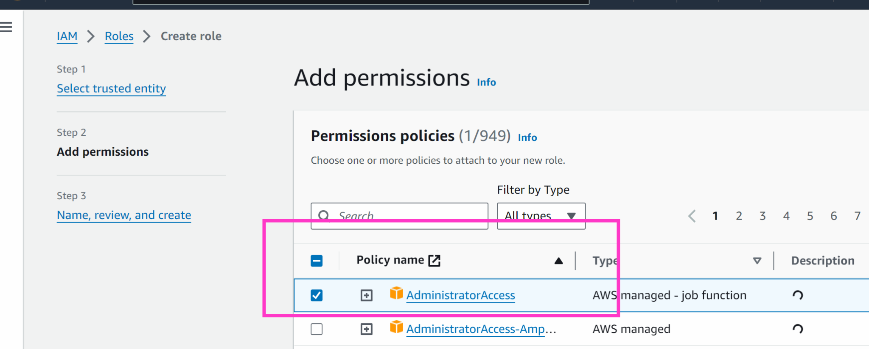

Next

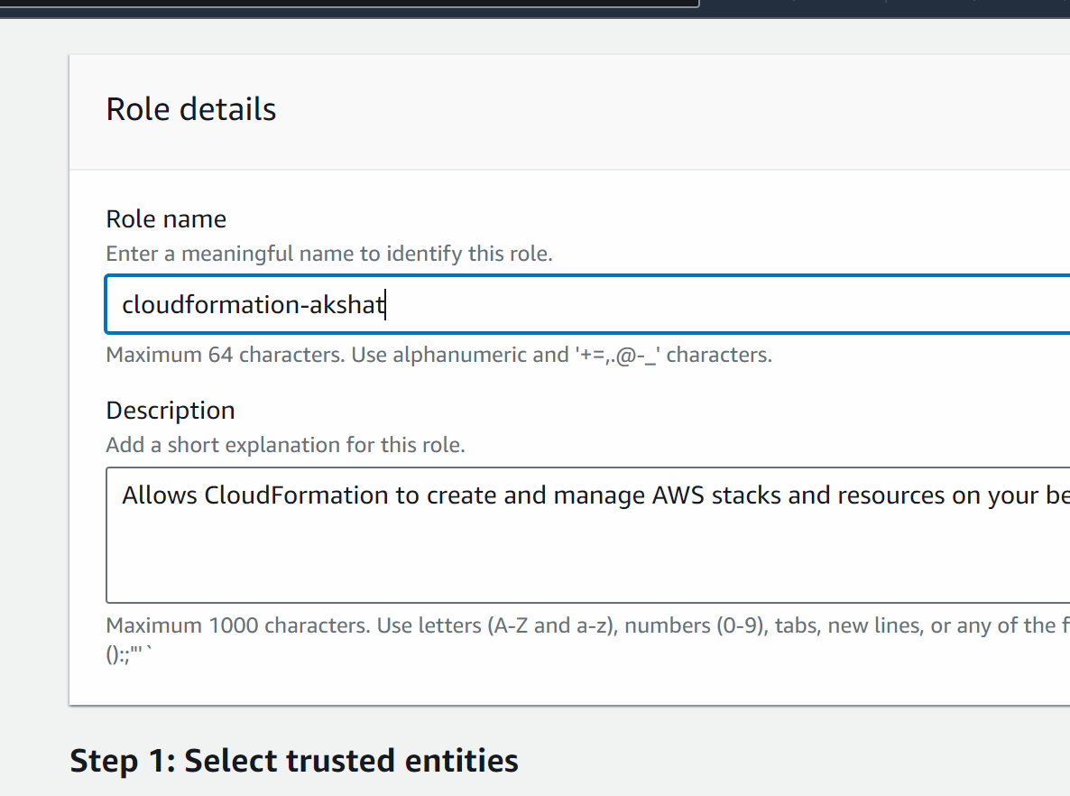
Create role
Go back to cloudformation tab

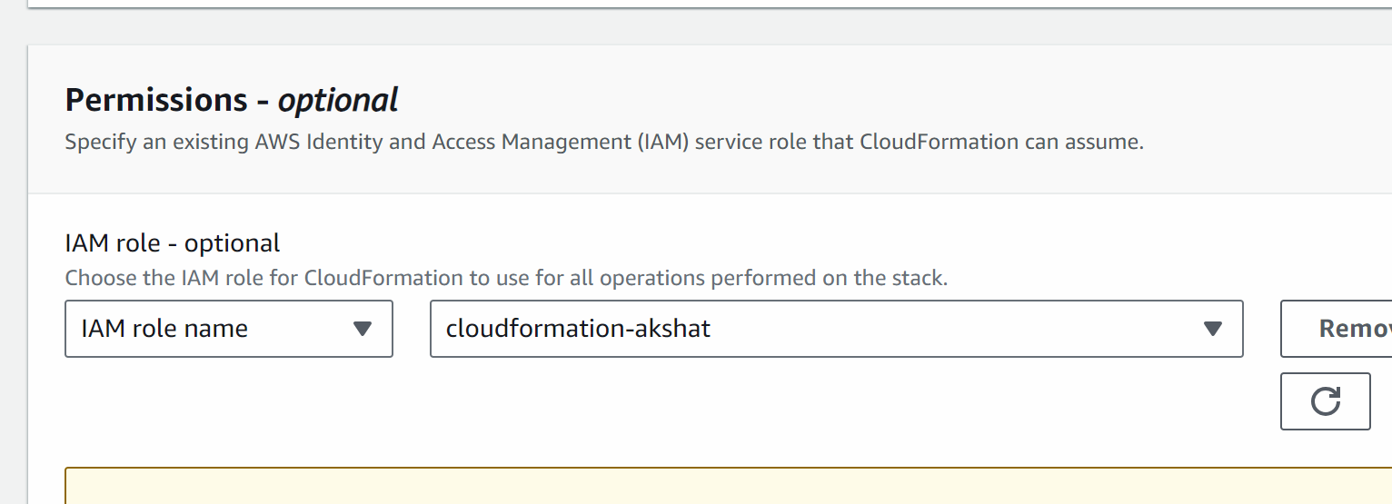
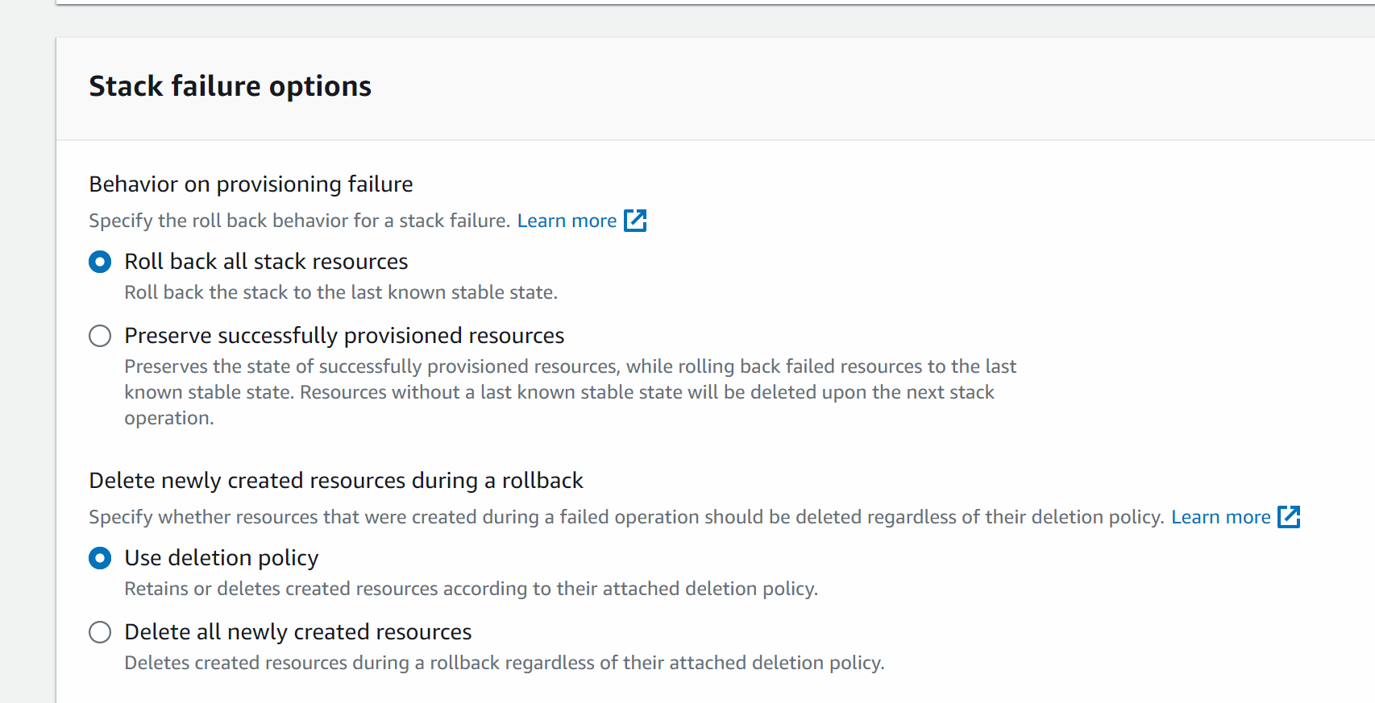

Submit

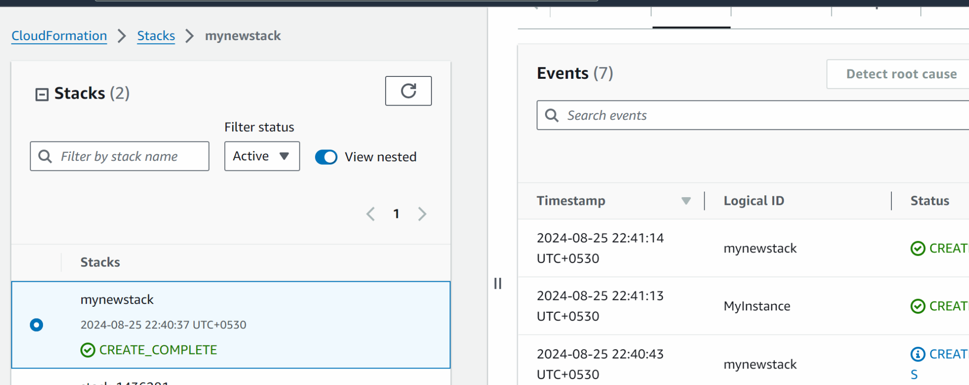

Now lets see the resource which we have created

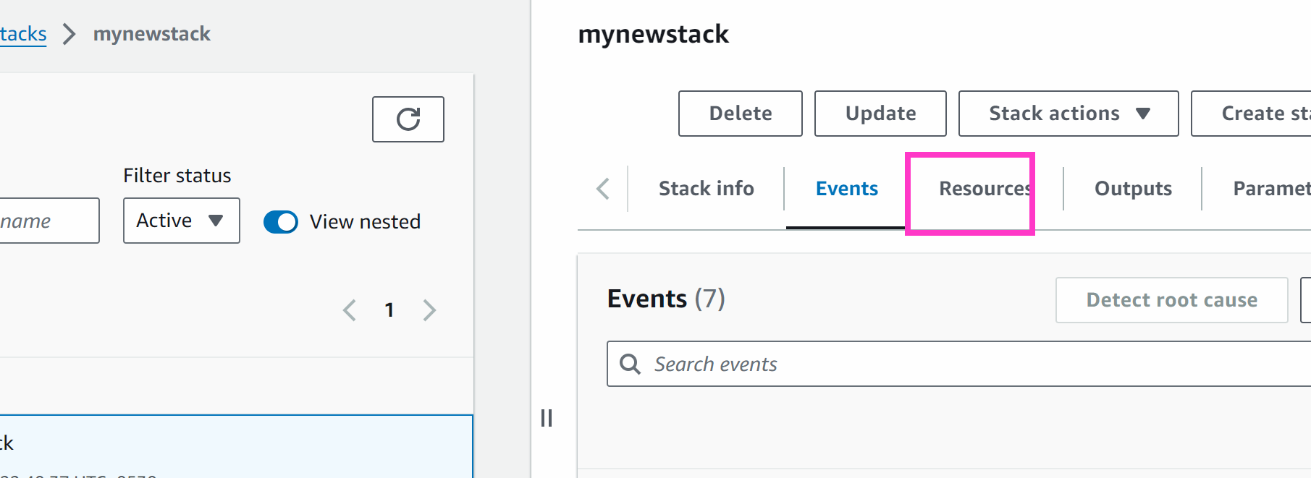

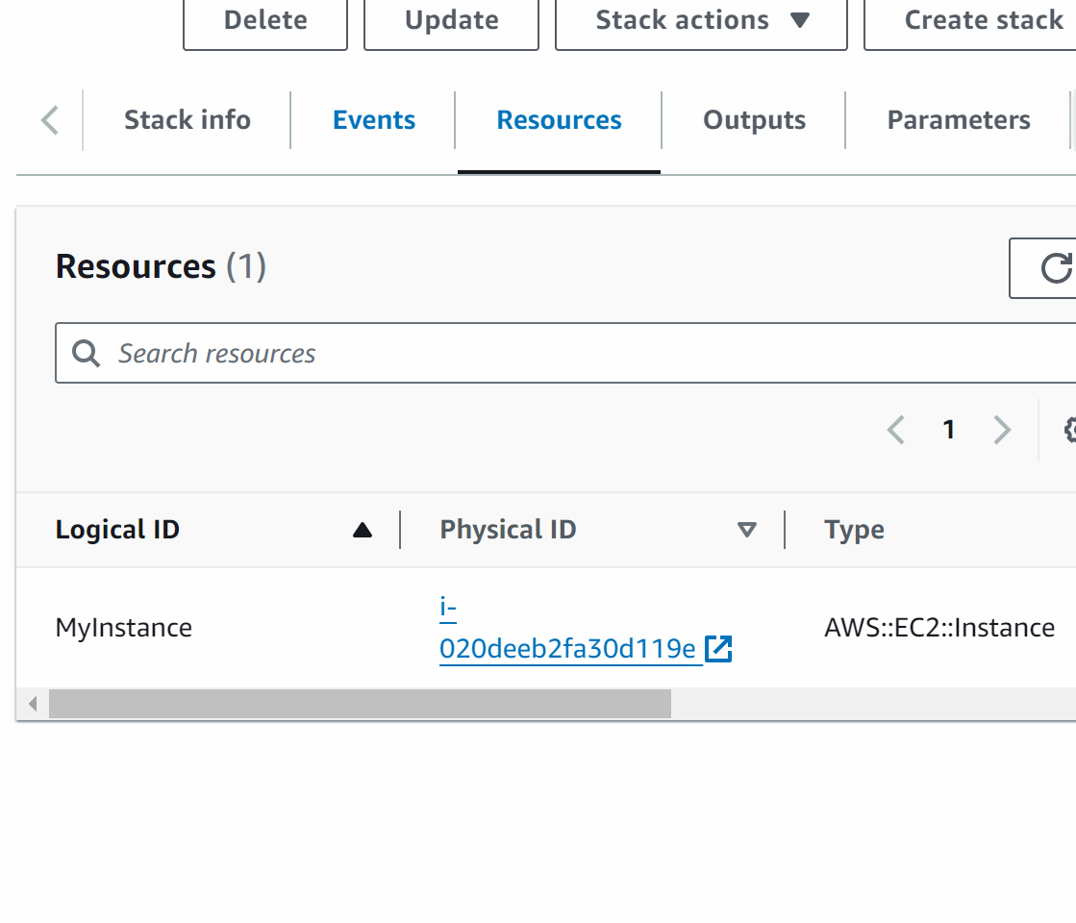

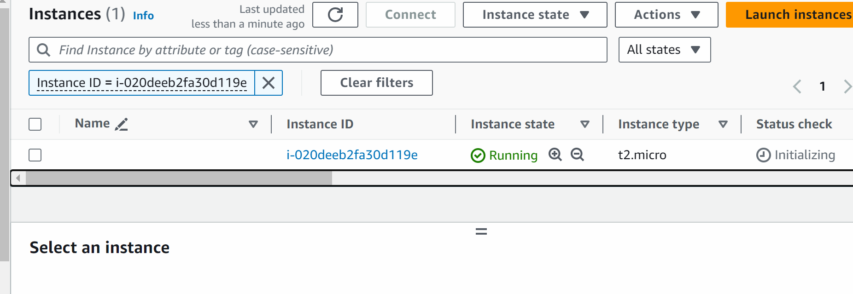

This machine is created via terraform cloud formation !!!
## if you delete the stack the resources associated with it will also be deleted

###############

Using parameters for cloud formation:

https://drive.google.com/file/d/1JfEe1xjBWKAxvF1A5sImBvRYwIOkD9xG/view?usp=drive_link

